National Park Service  U.S. Department of the Interior | Great Basin National Park  Use the complete site name here (e.g. Palo Alto Battlefield Historic Site). |  | 100 Great Basin National Park  Baker, Nevada 89311  775-234-7331 phone  775-234-7269 fax
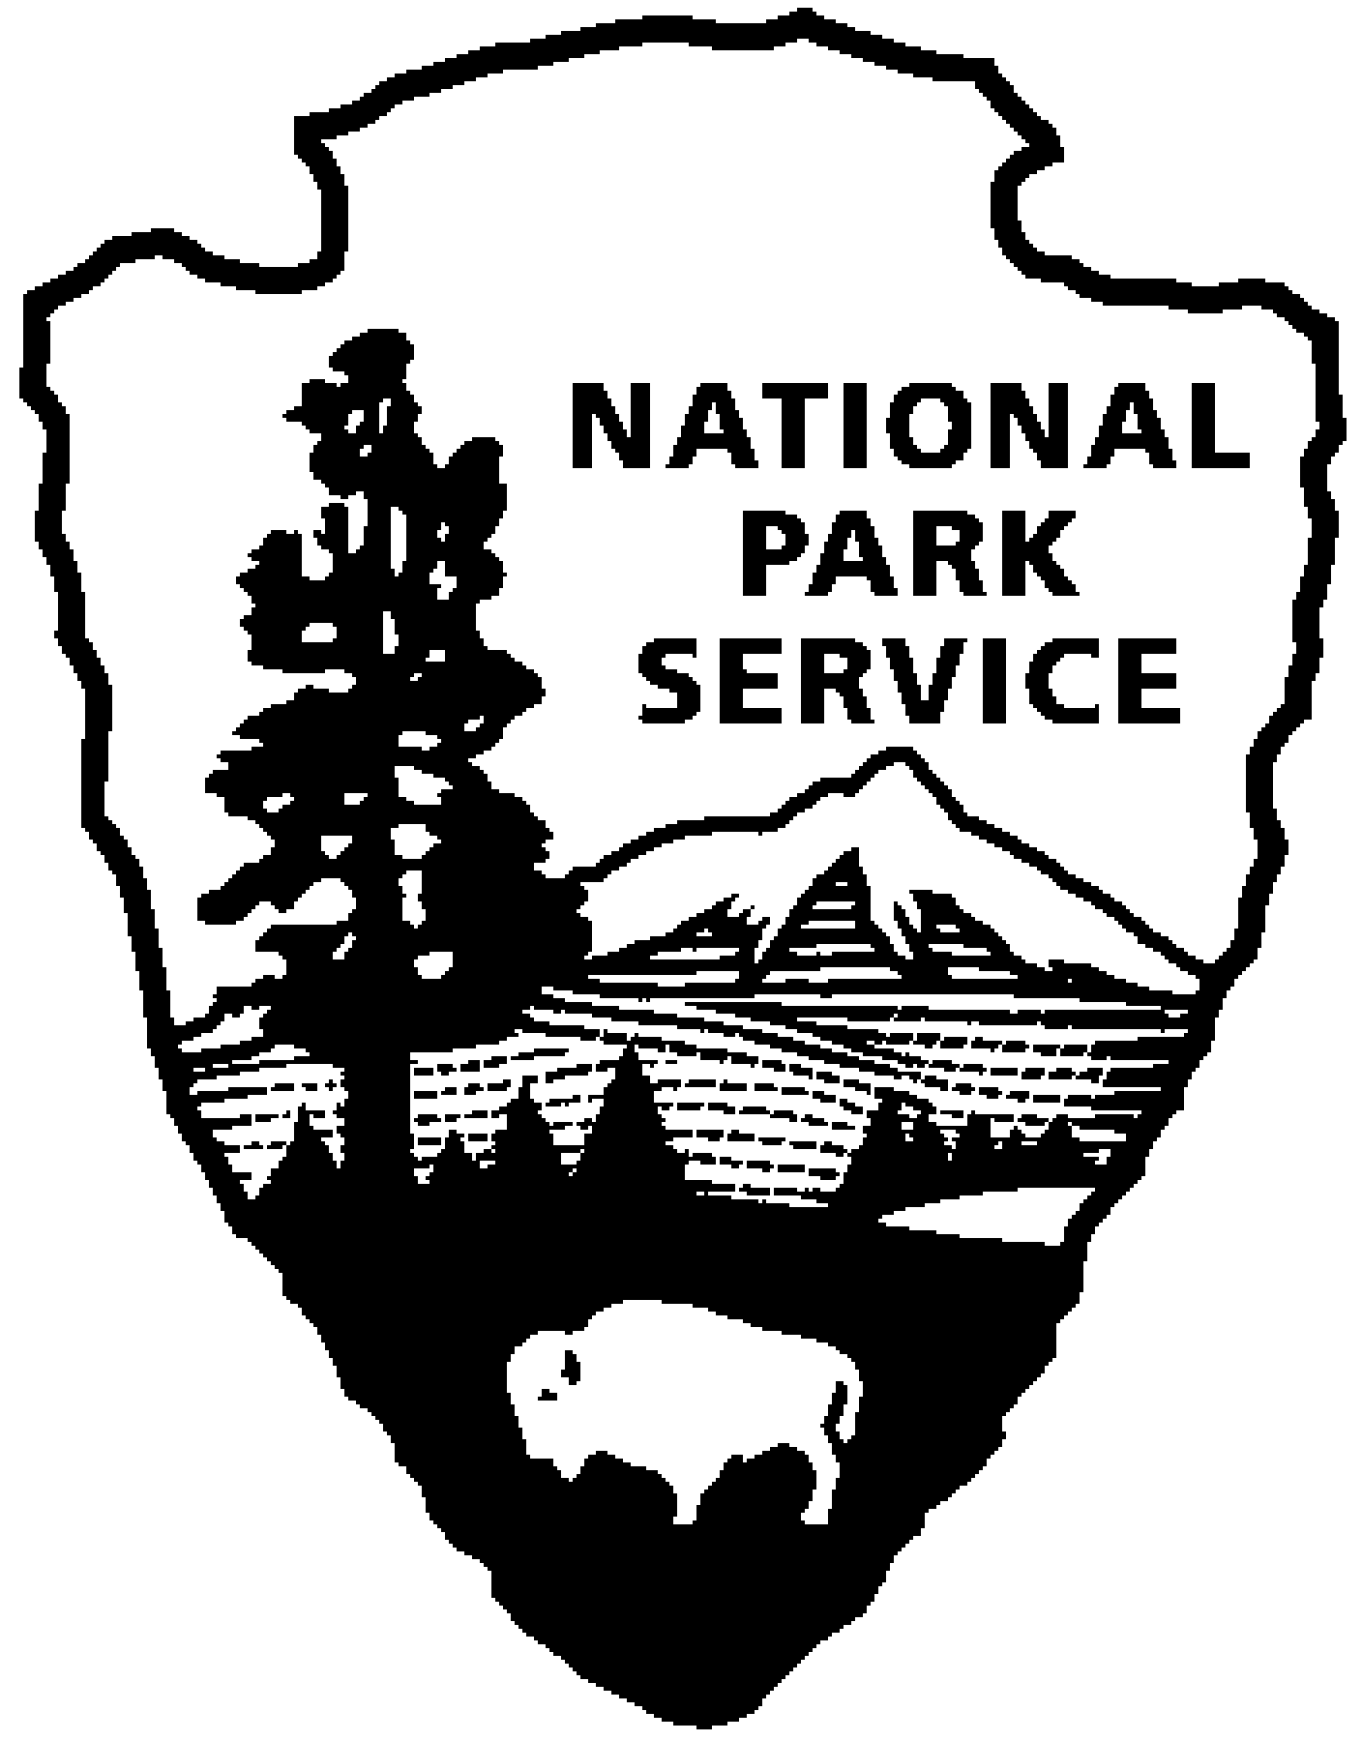
Great Basin National Park News Release
Use a “short-hand” version of the site name here (e.g. Palo Alto Battlefield not Palo Alto Battlefield National Historical Site).

Release Date: Immediate

Contact: Betsy Duncan-Clark, Supervisory Park Ranger

Phone Number: (775) 234-7331

Date: May 22, 2007

Great Basin National Park Announces Opening of Wheeler Peak Scenic Drive
and other Facilities for the 2007 Summer Season

The Wheeler Peak Scenic Drive in Great Basin National Park near Baker, Nevada, is now open to traffic for the season. The 12-mile Wheeler Peak Scenic Drive has 8 ½ % grades and hairpin turns. This road is not recommended for vehicles longer than 24 feet. In addition, the Wheeler Peak Campground at the end of the Scenic Drive is open for camping. Water will be available once temperatures rise to allow the water system to operate without freezing. Camping fees at Wheeler Peak Campground are $6 per night without water and will rise to $12 per night once the water system is activated. Baker Creek, Lower Lehman Creek and Upper Lehman Creek Campgrounds are all open for the season and water is available at those locations. Camping fees for these campgrounds are $12 per night. Camping is half of the posted price at all park campgrounds for U.S. citizens who hold a valid Golden Age, Golden Access, the National Parks and Federal Recreation Lands Senior or the National Parks and Federal Recreation Lands Access Pass. The RV dump station located near the Lehman Caves Visitor Center is open for the season. There is a $5 fee for use of this facility.

Hiking trails in the lower elevations of the park are mostly snow-free and dry. Trails in the higher elevations may still have significant snow cover. In particular, the Bristlecone Trail located at the end of the Wheeler Peak Scenic Drive is still approximately 90% snow covered with snow a few feet deep in locations. Snow shoes may be necessary to traverse parts of the trail. Trail and weather conditions can change quickly, so it is advisable for visitors to check at one of the park visitor centers for current information before beginning a hike, back-country or camping trip. Information for planning a visit to the park can be obtained by calling 775-234-7331 or by visiting the park website at www.nps.gov/grba.

Starting Friday May 25, 2007 through Monday September 3, 2007 the Lehman Caves Tour Schedule will include 60 minute tours daily at 8:30 a.m., 10:30 a.m., 12:30 p.m., 2:30 p.m. and 4:00 p.m.; and 90 minute tours daily at 9:00 a.m., 11:00 a.m., 1:00 p.m., and 3:00 p.m.. All times are Pacific Daylight Time. Holidays and weekends, Lehman Cave tours frequently sell out. To ensure a space on a tour visitors may purchase non-refundable advance tickets by telephoning (775) 234-7331 extension 242, from 9:00 a.m. to 4:00 p.m. Pacific Time Monday through Friday. Advanced cave tour tickets may be purchased with a major credit card from one to 30 days in advance of the desired tour on a space available basis. Tickets must be claimed in person at the Lehman Caves Visitor Center information desk no later than 20 minutes before scheduled tour time. Spaces for unclaimed tickets will go on sale to arriving customers. Golden Age and Golden Access Passports must be presented to be eligible for the discount. Unclaimed tickets cannot be refunded. Cave tours are limited to 25 participants. An adult must accompany children 15 years of age and younger. Fees for tours of Lehman Caves are as follows:

60-minute Tour Adult 16 years of age and older $8.00
Youth 5-15 years of age $4.00
Golden Age and Golden Access Passports $4.00
Infants and Toddlers (less than 5 years old) Free

90-minute Tour: Adult 16 years of age and older $10.00
Youth 5 through 15 years of age $5.00
Golden Age and Golden Access Passports $5.00
Children under 5 years of age not permitted

Interpretive staff will offer nightly evening programs at Upper Lehman Campground starting Friday May 25th and at Wheeler Peak Campground Friday and Saturday starting Friday June 29th. Programs are 45-60 minutes long and address subjects related to the Great Basin’s cultural and natural resources.

Throughout the summer look for Night Sky and Star gazing programs at the Great Basin Visitor Center. Saturday May 26th, join a park ranger at 7:30 p.m. for the summer season’s first program.

May 25th through September 3rd the Lehman Caves Visitor Center at Lehman Caves and the Great Basin Visitor Center in Baker, Nevada operate daily 8:00 a.m. to 5:30 p.m. Pacific Time.

The Park’s concession, Lehman Caves Gift & Café, will start their daily summer hours 8:00 a.m. to 5:00 p.m. Saturday May 26th. The kitchen closes at 4:00 p.m. The café serves breakfast and lunch. The gift shop carries a broad range of items with a nature or outdoor theme. The café and gift shop adjoin the Lehman Caves Visitor Center.

For further information, visit our website at www.nps.gov/grba or to receive an information packet phone (775) 234-7331 extension 0.

Come explore and enjoy Nevada's first and only National Park!

-NPS-
Great Basin National Park Superintendent Cindy Nielsen announced the new fee schedule effective Sunday, January 2, 2005.
Great Basin National Park Superintendent Cindy Nielsen announced the new fee schedule effective Sunday, January 2, 2005.

